EDUCATION FOR DEMOCRATIC CITIZENSHIP: THEORY AND TEACHING PRACTICE
Session 7/8 (1st): Education for Democratic Citizenship and Human Rights Education: Cross-curricular implementation
Collaboration in Informatics Lessons
Activity 1: Transformative learning through art: the case of collaboration in Informatics lessons
Agoritsa Gogoulou

Educational Framework
In the context of the school education process, students are invited to participate in collaborative activities of two or more persons. Collaboration is proposed in the curriculum of informatics courses at all grades. Due to the nature and conditions of the course, the students are usually invited to work together in pairs in front of a computer and using a computer.
Groups may be formed on the basis of students’ preferences or according to the teacher’s selection criteria. The characteristics of each student, the relationship between them and the use of the computer shape the climate and the outcome of the collaboration. Students’ attitudes that one may observer while they collaborate in front of the computer invlove
- one member is passive while the other has the control of mouse/keyboard-controlled and working
- one member is going to laze and attempts to chat with other groups
- members argue with each other about the process and the outcome of the work
- one member attempts to control the mouse/keyboard and "drive" the job
Smooth and fruitful collaboration is a major objective of both the educational process in general and the informatics courses in particular.

Identification of the need for critical investigation of the issue
The above-mentioned behaviors are often observer in informatics lessons. The students’ attitude and their emerging beliefs converge towards the opinion that these behaviors are normal, acceptable and effective. Students’ beliefs are expressed as follows:
"My classmate thinks that she is know-it-all and always complains. She says that I’m not helping, but she doesn’t let me to do so. I'm terribly bored. I work only when I'm alone."
"My classmate is so bored. He doesn't even know how to open a computer, and all he does is copy-paste. He is a very good friend of mine as he doesn’t bother me. He knows nothing … "

Specification of the critical questions
The majority of students recognize that the collaboration is important and that all members should actively participate and contribute. However, it seems that some students can’t easily accept their partner and prefer to work on their own.
Given the situation, two subtopics were raised for investigation:
- members communicate in front of the computer
- contribution of the members of the group
Critical questions:
1st. Why and how does the computer affect the communication of group members when they "collaborate"?
2nd. How do I act and how do I consider my involvement in group's work?

Selection of works of art and correlation with critical questions
In order to process the two question, two visual works and a movie were chosen as appropriate to address the above issues of collaboration.
1st artwork
Type | Painting
Title | Working at computers
Artist | Edouard Sacaillan
Characteristics | Oil on canvas (40.2 x 47 cm)
Year | 2000
Source | https://felioscollection.gr/en/collection/ergazomeni-stous-ipologistes/
Museum
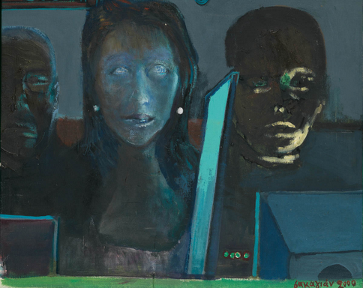

The painting is mainly related to the first critical questions. The teacher should guide the students to focus on the three faces, to comment on the gender of the three persons and on their look and express their feelings.
2nd artwork
Type | Painting
Title | Two Girls Reading
Artist | Pablo Picasso
Characteristics | Oil on canvas (81.8 x 65.3 cm)
Year | 1934
Source | http://www.wikiart.org/en/pablo-picasso/two-figures-1934
Museum | University of Michigan Museum of Art
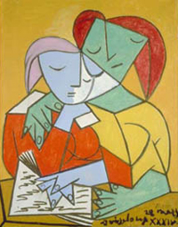

The painting is related to both critical questions. The teacher should guide the students to focus on the two figures, to comment on their characteristics, to observer their way they approach and page through the book.
3rd art wok
Type | Film
Title | Take the lead
Director | Liz Friedlander
Year | 2006
Country | USA
Πηγή
Excerpt of the film | The end of the movie
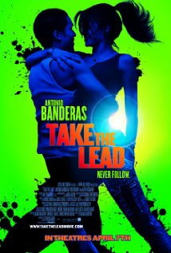

The movie is mainly related to the 2nd critical question. The story concerns a tango-teacher in New York. He decides to work in a disreputable schools with high degree of juvenile delinquency. The students behave in a derogatory manner and they don’t care for learning to dance. The teacher keeps trying to stimulate them and eventually he managed to prepare them for taking part in a dance contest. The excerpt chosen focuses on the different characteristics of the students, on their collaboration, and how they impressed the rest participants and the organizing committee.
The teacher should guide the students to focus on the students’ different physical characteristics and how they collaborated and formed their pairs, by exceeding the stereotypes of the two genders and the dancers’ shapely bodies.
4th artwork
Type | Painting
Title | Double Tent
Artist | Paul Klee
Characteristics
Year | 1923
Source | http://newabstraction.net/2012/11/13/modernist-method/
Museum | Museum Sammlung Rosengart, Luzern
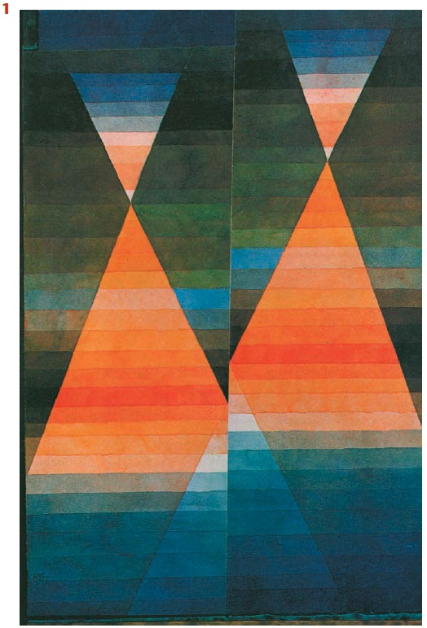

The artwork is related to the 2nd critical question. It is focused on the harmony and complementarity of colours.

Artworks | Relation to critical questions
 | 1st | 2nd
Working at Computers
Two Girls Reading
Take the lead
Double Tent

Critical elaboration of the artworks
The teacher presents consecutively the three artworks and asks and encourages all students to watch closely and express freely their views on what they see. Each piece is analysed and critically connected to the critical questions. The teacher may elicit students’ answers by asking questions and prompts such as
- What do you see (or read or hear)?
- Why are you saying this? What do you see (or read or hear) that makes you to consider this?
- What are your thoughts and feelings?
- Keep on! Try to discover new elements! Try to find any symbols or marks? What is the symbolic meaning of …?
- Pay attention to the details! Why does the artist use these colours?
In the end of the intervention, the teacher supports and facilitates a critical reflection on the previous discussions and tries to reveal students’ current views in comparison to the initial ones. Also, the students may express their impression of what they experienced.
Instead of oral communication throughout the whole process, the teacher may ask students to express their initial beliefs and their beliefs after the application of the method, in written form.

